1. Introduction
   1. Project Pico includes a few key features. The most important feature of the project is the Photos page. This page is designed to create user engagement and build an audience. The site also will allow people to sign in and interact with the site including like content (for example giving a thumbs up to a photo similar to Instagram). The site also includes pages like a Favorites page, a Contact page, and an About page.
2. Design and Implementation
   1. The system relies heavily on HTML, CSS (and SCSS), Bootstrap, Bootstrap Social, FontAwesome, and Google Fonts for the front-end. The business logic uses JavaScript, jQuery, Popper.js, Bootstrap.js components to create interactivity with the end user. The site also has Google Analytics embedded to track site analytics. I’ve also deployed the site using AWS Amplify and registered the domain with AWS Route 53. The implementation includes Bootstrap components like Cards, Carousels, Modals, Forms, Buttons, Navbar, and heavy use of Flexbox.
   2. The design phase took multiple routes. I used Moqups for portion of the design and I also designed some of the pages on scratch paper using a wireframe approach. In terms of going from design to code, I relied on Bootstrap’s documentation pages quite a bit while coding. I also reviewed the source code for web pages like Instagram to get ideas on how to turn my design into code.
   3. I originally intended this site to require a user login; however, I decided to make the entire site public because I haven’t learned how to implement more of the backend tools like a database.
   4. The Bootstrap framework was critical in building my site. Bootstrap made the implementation far easier with access to the components, layouts, and utilities. I am also using jQuery as my JavaScript library, which provided an easy way to implement user interactivity on things like modals and carousels. Using Bootstrap and jQuery are a logical choice because much of the heavy lifting is already packaged for you. So instead of having to focus on the really in-depth technical implementation, you can instead use the DRY (don’t repeat yourself) and use libraries and frameworks that have already solved the technical problem that you need to implement.
   5. 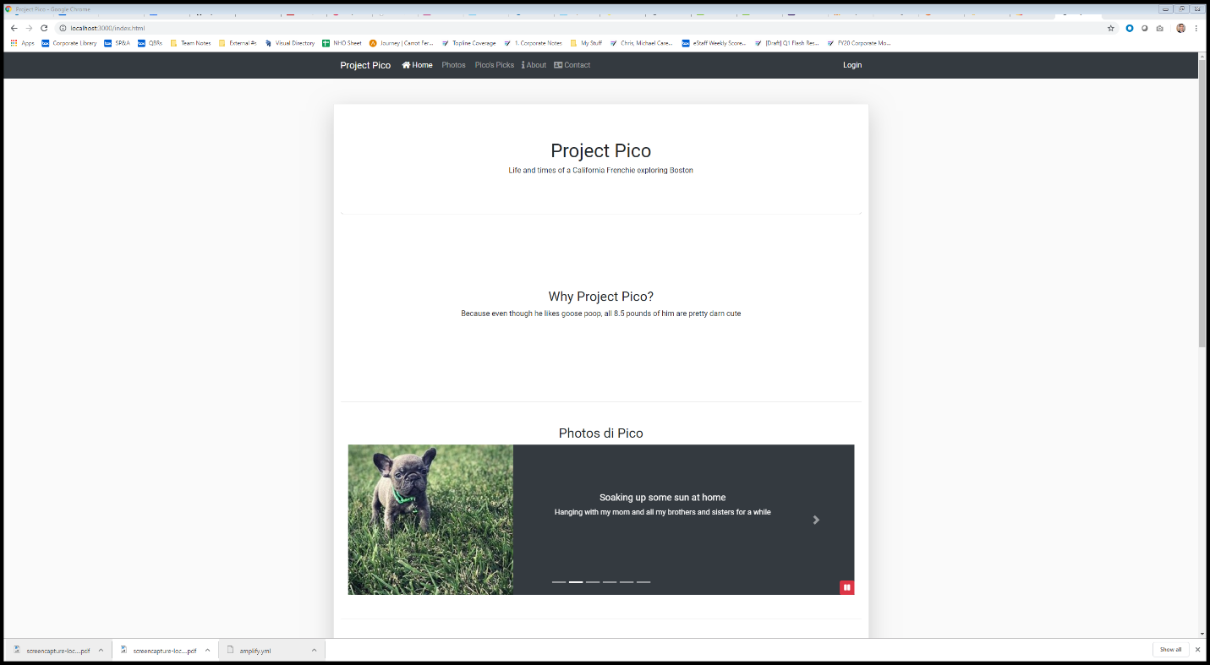
   6. 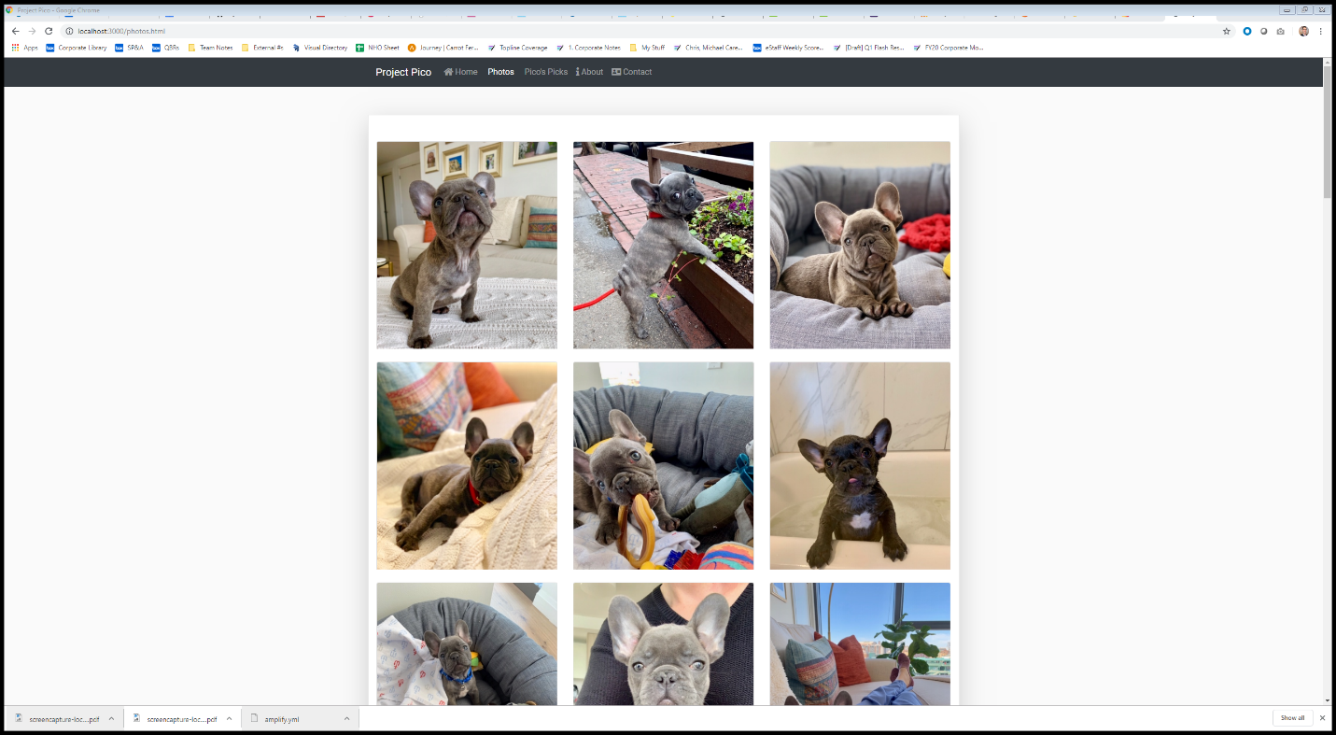
   7. 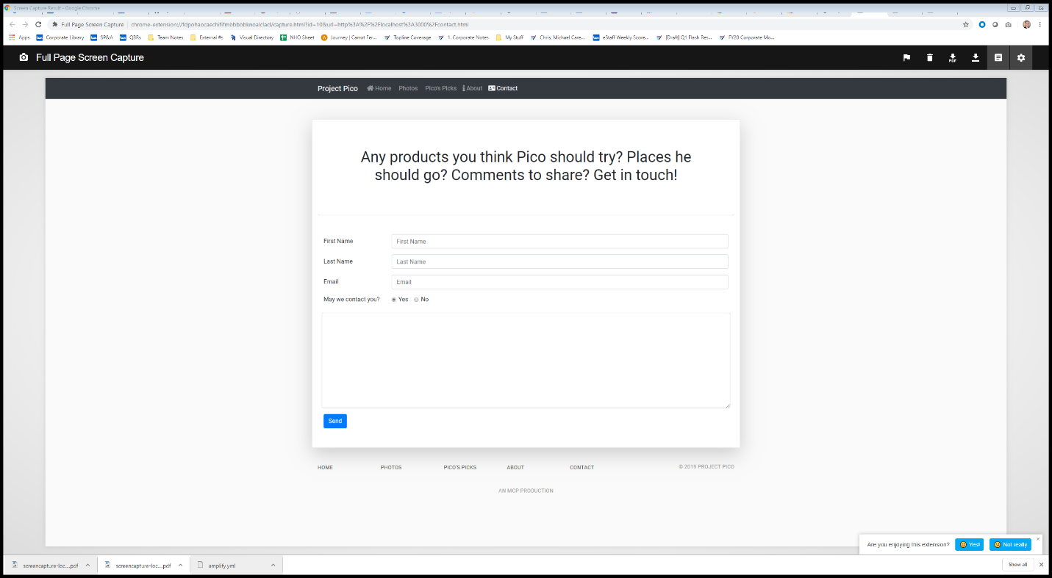
3. Conclusions
   1. From this project, I implemented my first real website and deployed it to the public using AWS
   2. The biggest thing I need to learn to further my project is back-end development so I can attach a database and require user login credentials.
   3. I might have studied design principles more before starting the project. Any great website also has great design. And I am only scratched the surface of good design principles
4. References:
   1. <https://getbootstrap.com/docs/4.3/getting-started/introduction/>
   2. [www.instagram.com](http://www.instagram.com)
   3. <https://sass-lang.com/install>
   4. <https://fonts.google.com/>
   5. <https://aws.amazon.com/>
   6. <https://fontawesome.com/>